1. What is JAVA
2. History of java
3. Features
4. Java architecture
5. Coding standard

WHAT IS JAVA?

1. **Java is a object oriented programming Structure language**.
2. Writing, Compiling and debugging Is easy
3. It can be reusable

History of Java Programming Language

1. [**James Gosling**](https://www.javatpoint.com/james-gosling-father-of-java) initiated the Java language project in June 1991
2. Firstly, it was called **"Greentalk"** by James Gosling
3. After that, it was called **Oak** and was developed as a part of the Green project
4. Oak is a symbol of strength and chosen as a national tree of many countries like the U.S.A., France, Germany, Romania, etc.
5. In 1995, Oak was renamed as **"Java"**

FEATURE/ IMPORTANCE JAVA? WHY WE GO FOR JAVA?

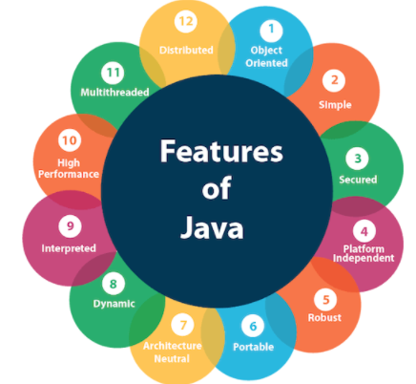

1. Platform Independent 🡪 Java compiler converts Source code to Byte code in any platform.

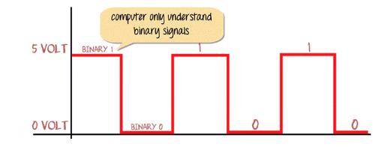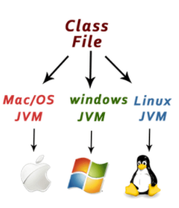

1. Open source 🡪 Free Of Cost
2. Secure 🡪 virtual firewall between Application & Computer.
3. Multi-thread 🡪 ticket booking
4. Multi-tasking🡪 Whats App
5. Portable 🡪 WORA (Write Once Run Anywhere)

JAVA ARCHITECTURE WITH EXAMPLE

|  |  |  |
| --- | --- | --- |
| **JDK** | **JRE** | **JVM** |
| To develop JAVA code | Helps to run program | Used for memory allocation |
| Java Development Kit | Contains pre-defined library files | Not physically exist |
| Version 1.0 - 1.18 | Java Run time environment | Java Virtual Machine |
| Standard Version - 1.8 |  |  |

CODING STANDARD WITH EXAMPle

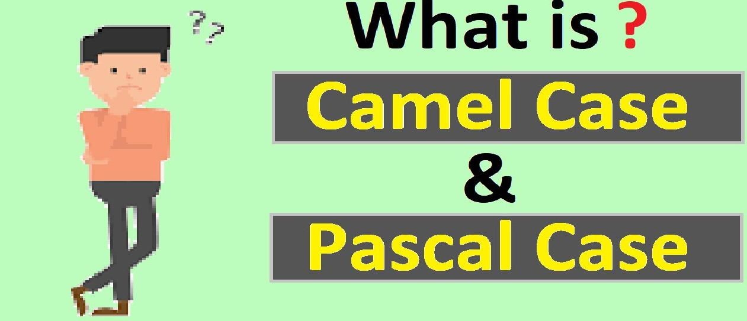

PASCAL🡪 Every word 1st letter must be Capital. [Project/Class Name]

Eg: Employee_Details

CAMEL🡪 every 1st word remaining word 1st letter must be capital.

[Object/Method/Variable]Eg: employee_Detail_Capgemini

Package-com.name/org.name

File-🡪new--🡪java project---🡪

New--🡪 package-🡪class

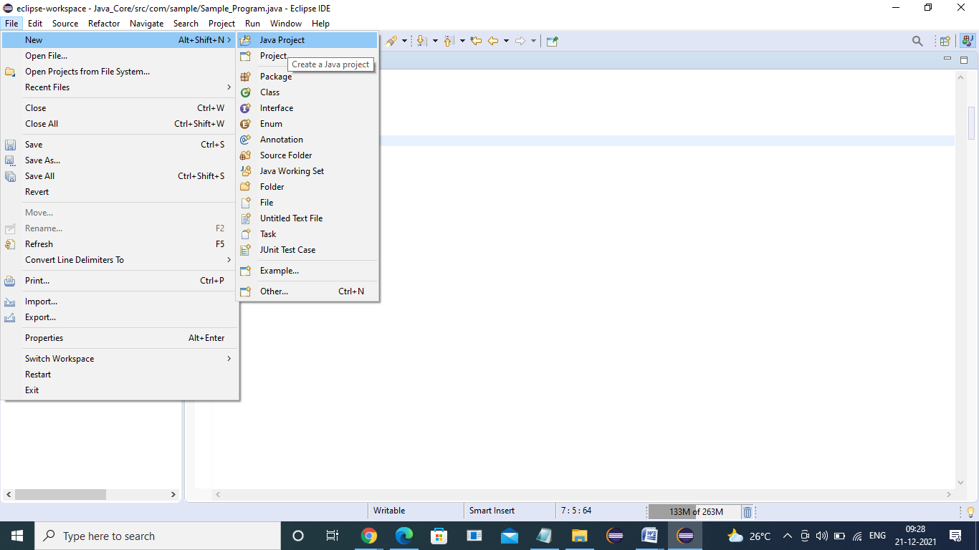

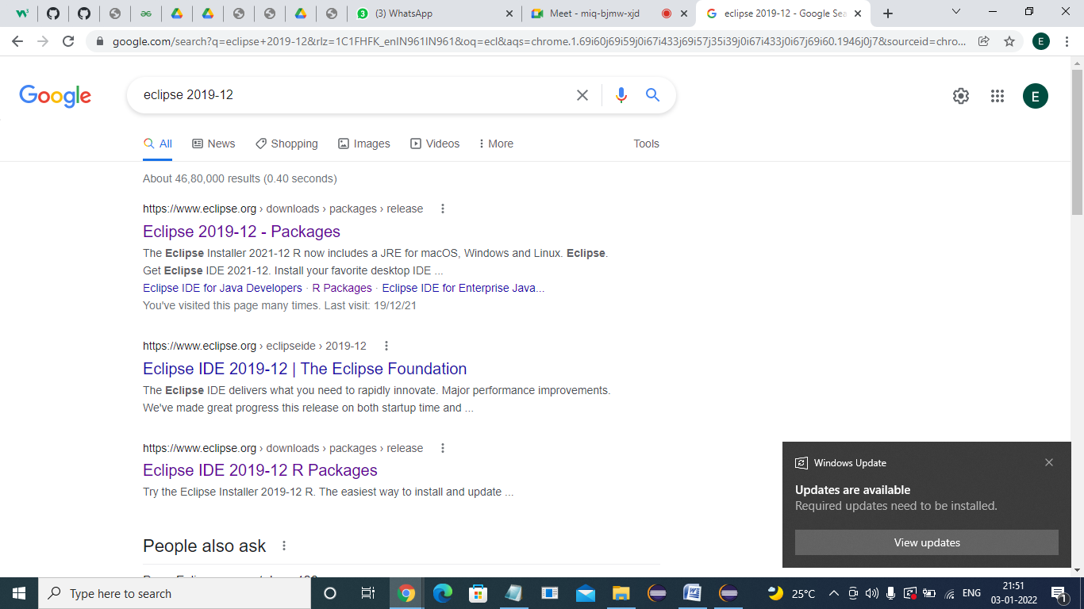

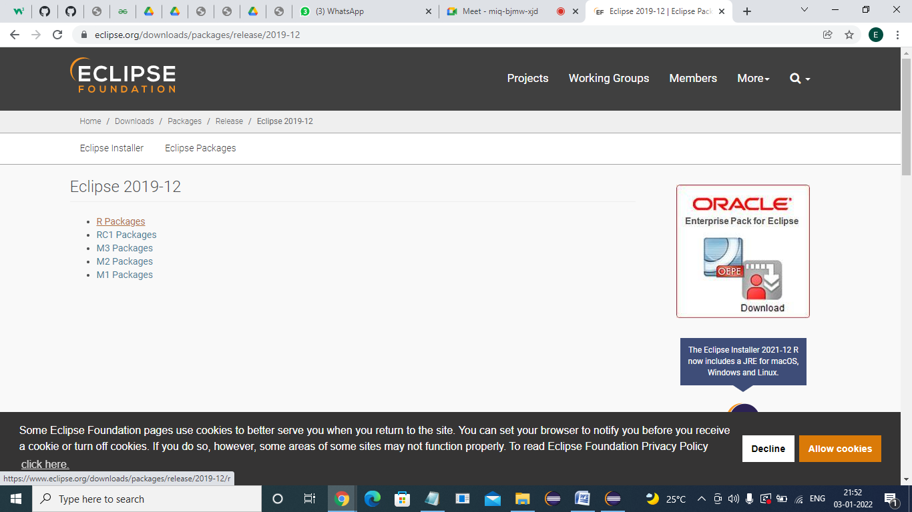

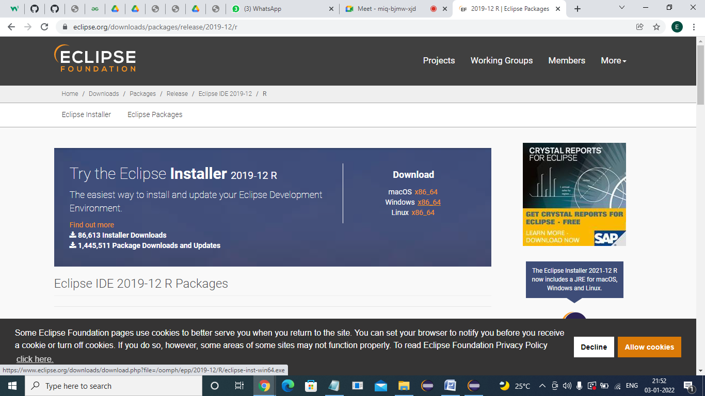x

